EMPLOYEE DEPARTMENT ANALYSIS

- Create the Employee Table as per the Below Data Provided
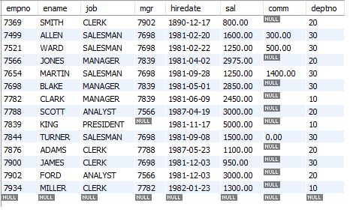
Note : Ensure the Salary cannot be Less then Negative or Zero
Deptno Should be foreign key. Referring to the Dept dept Table created in Step 2
Empno cannot be null or Duplicate.
Default Job should be Clerk

- Create the Dept Table as below
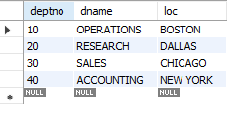
- List the Names and salary of the employee whose salary is greater than 1000

- List the details of the employees who have joined before end of September 81.

- List Employee Names having I as second character.

- List Employee Name, Salary, Allowances (40% of Sal), P.F. (10 % of Sal) and Net Salary. Also assign the alias name for the columns

- List Employee Names with designations who does not report to anybody

- List Empno, Ename and Salary in the ascending order of salary.

- How many jobs are available in the Organization ?

- Determine total payable salary of salesman category

- List average monthly salary for each job within each department

- Use the Same EMP and DEPT table used in the Case study to Display EMPNAME, SALARY and DEPTNAME in which the employee is working.

- Create the Job Grades Table as below
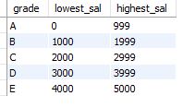
- Display the last name, salary and Corresponding Grade.

- Display the Emp name and the Manager name under whom the Employee works in the below format .

Emp Report to Mgr.

- Display Empname and Total sal where Total Sal (sal + Comm)

- Display Empname and Sal whose empno is a odd number

- Display Empname , Rank of sal in Organisation , Rank of Sal in their department

- Display Top 3 Empnames based on their Salary

- Display Empname who has highest Salary in Each Department.

